Feature : Notification centre

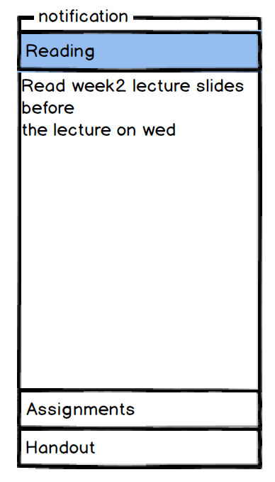

Notification content

Categories of notification

A webpage on notification centre, where students can get notification from lecturers.

When a student click on the notification one of the notification categories, that category will be highlighted and list its notification content.

Feature: Course Home Page

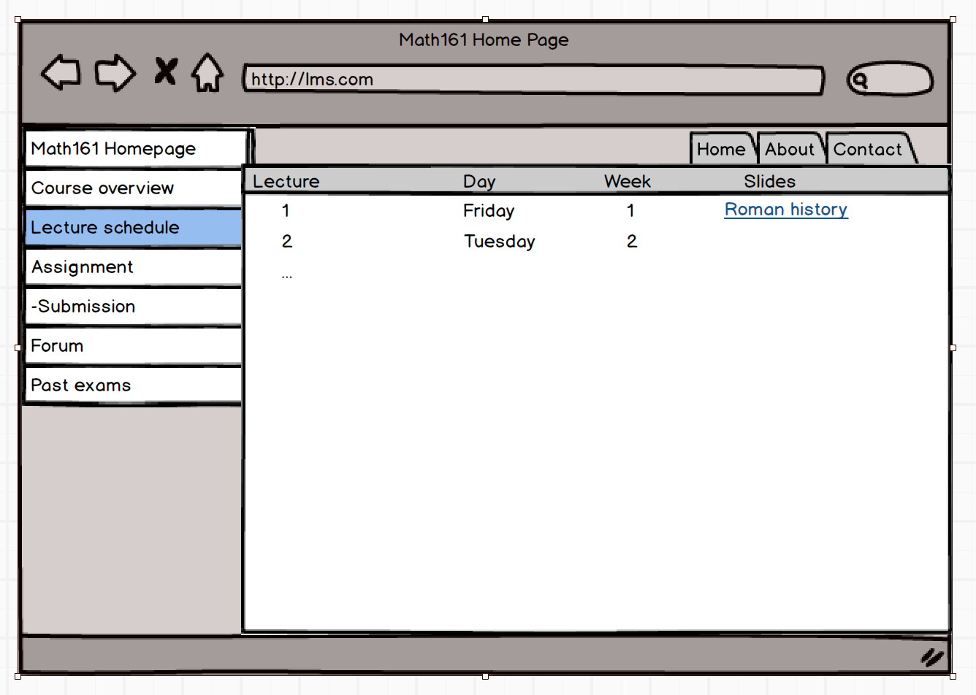

Each paper has its own home page, which allow student to browse course material.

Feature: Video Stream

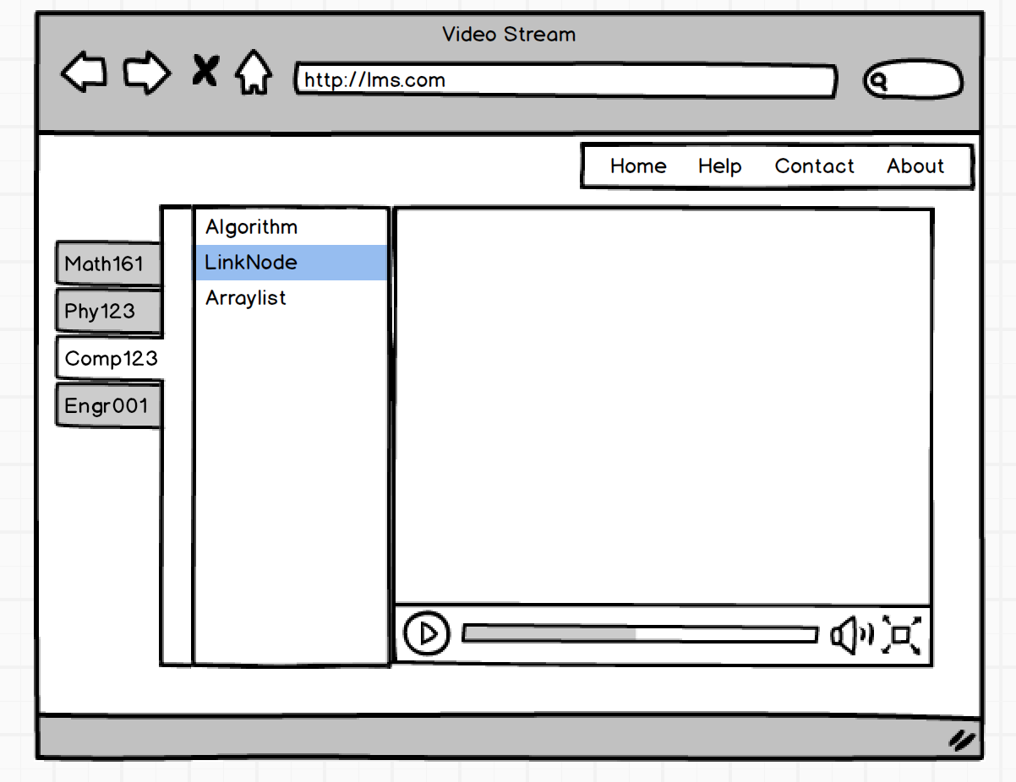

Some student might skip some lectures, therefore, we set up this video stream for student to catch up their lectures.

Feature: Help Centre

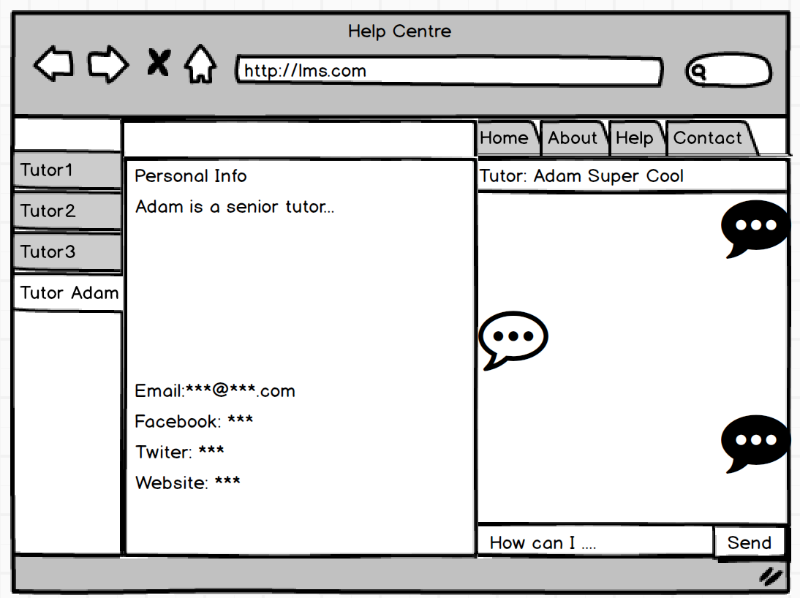

Student can chat with the tutor who is online, asking them for help.

Feature: Mock Exam Centre

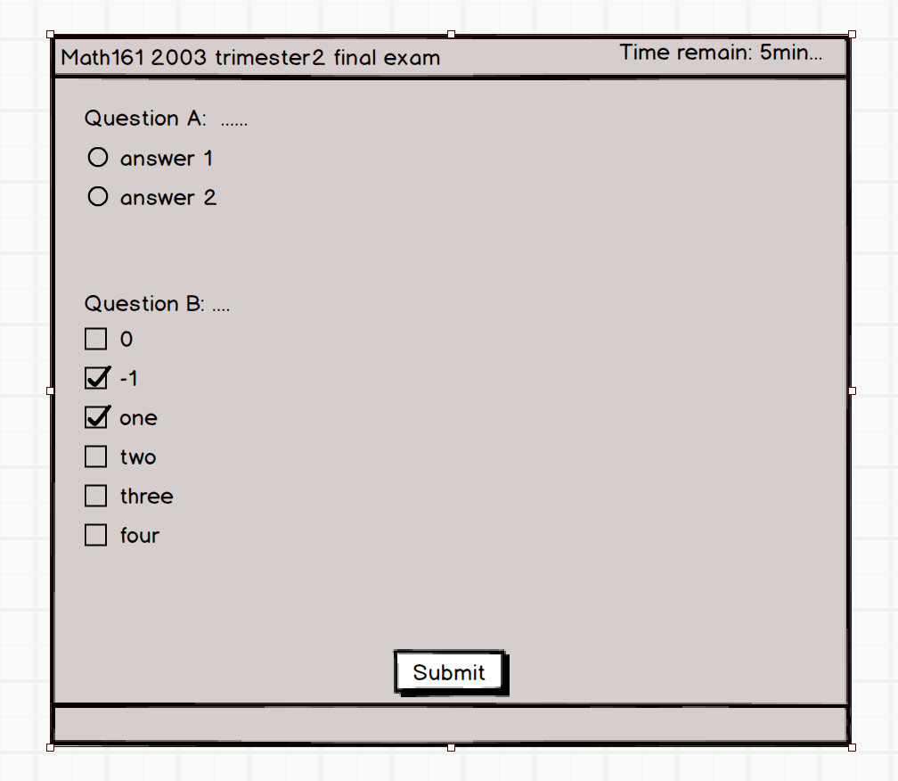

The mock exam centre can help student prepare for the final.

Student can test themselves by choosing any past exams and after the mock exam. They can receive their marks in 3 days. The marks will be given by tutors or software. It depends on the types of the exams.